Decagonal Antiprism
# Source: AI Source: Provided by: [Data Path: Persons Table -> ID Column: 1, Name_En Column: Motasem Essam] -> From: [ChatGPT] on [7/25/2026]
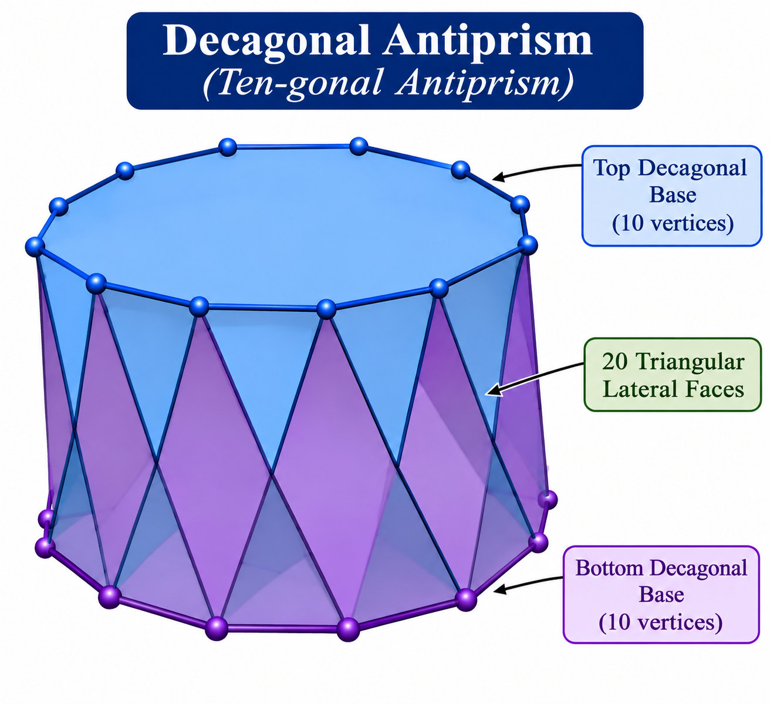

Definition
# Source: AI Source: Provided by: [Data Path: Persons Table -> ID Column: 1, Name_En Column: Motasem Essam] -> From: [ChatGPT] on [7/25/2026]
A Decagonal Antiprism is a polyhedron consisting of two parallel, congruent decagonal bases, with one decagon rotated relative to the other. The bases are connected by twenty triangular lateral faces.
It is a type of antiprism with decagonal bases and a twisted arrangement of its lateral triangles.
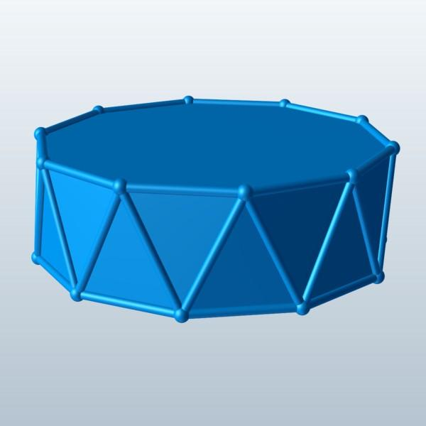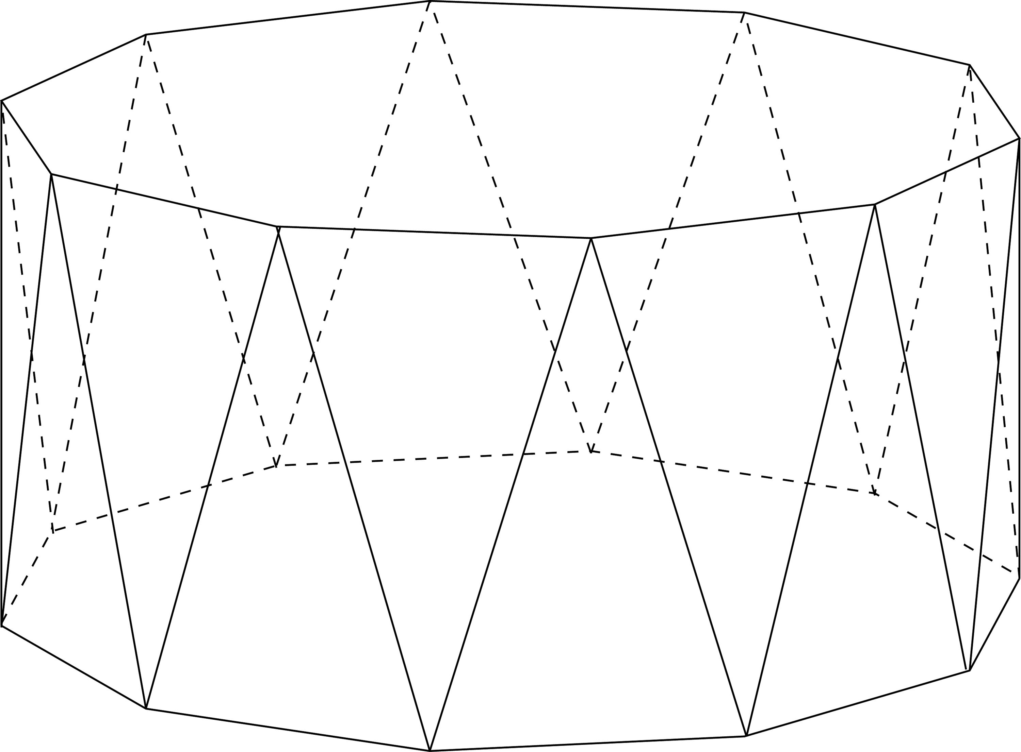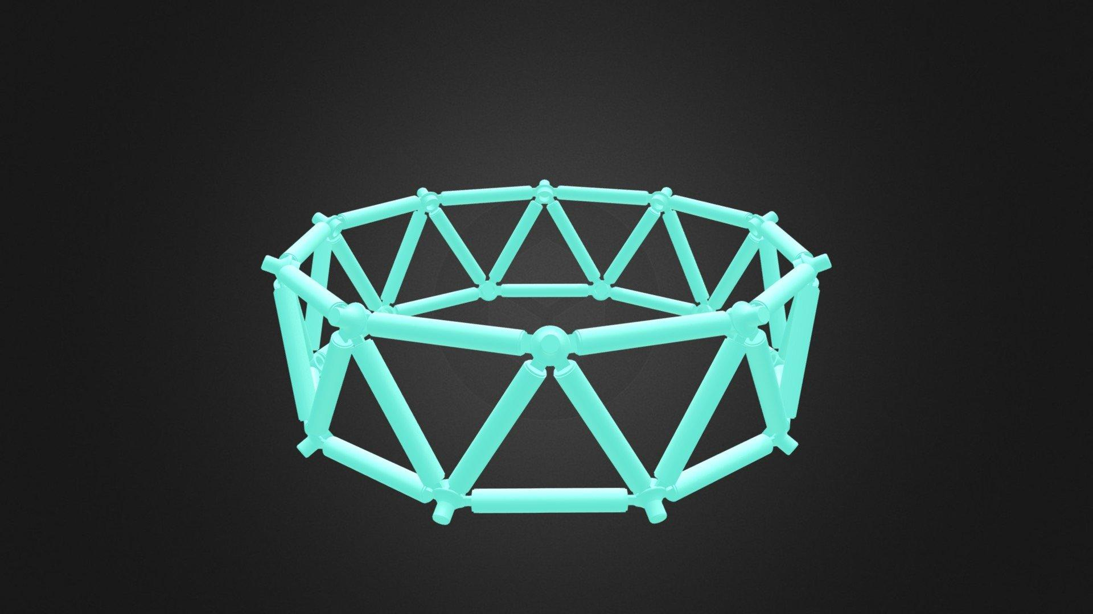

Geometric Structure
# Source: AI Source: Provided by: [Data Path: Persons Table -> ID Column: 1, Name_En Column: Motasem Essam] -> From: [ChatGPT] on [7/25/2026]
The decagonal antiprism consists of:
- Upper Decagonal Base: A decagon forming the top face.
- Lower Decagonal Base: A congruent decagon forming the bottom face, rotated relative to the upper base.
- Triangular Lateral Faces: Twenty triangles connecting the two decagonal bases.
- Vertices: Twenty vertices, with ten on each base.
- Edges: Forty edges connecting the vertices.

Face Composition
# Source: AI Source: Provided by: [Data Path: Persons Table -> ID Column: 1, Name_En Column: Motasem Essam] -> From: [ChatGPT] on [7/25/2026]
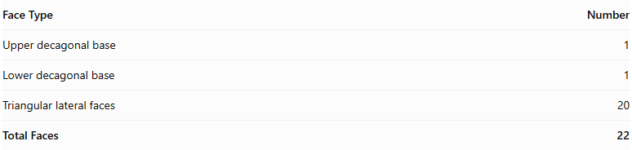
Face Type | Number
Upper decagonal base | 1
Lower decagonal base | 1
Triangular lateral faces | 20
Total Faces | 22

Mathematical Properties
# Source: AI Source: Provided by: [Data Path: Persons Table -> ID Column: 1, Name_En Column: Motasem Essam] -> From: [ChatGPT] on [7/25/2026]
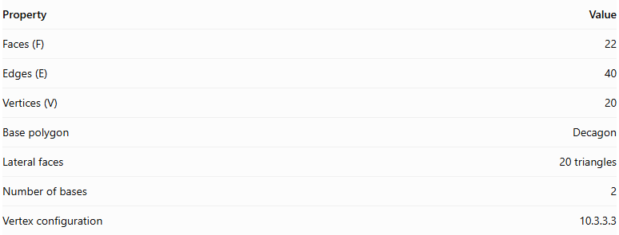
Property | Value
Faces (F) | 22
Edges (E) | 40
Vertices (V) | 20
Base polygon | Decagon
Lateral faces | 20 triangles
Number of bases | 2
Vertex configuration | 10.3.3.3
Euler's formula:
$$V-E+F=2$$
$$20-40+22=2$$
Regular Decagonal Antiprism
In a regular decagonal antiprism:
- Both decagonal bases are regular and congruent.
- The upper and lower bases are rotated relative to each other, typically by ${18}^{∘}$.
- The twenty lateral triangular faces are equilateral.
- The vertices have the same local arrangement.

Constructing Decagonal Antiprism in Solid Geometry

Geometric Instruments Used
# Source: AI Source: Provided by: [Data Path: Persons Table -> ID Column: 1, Name_En Column: Motasem Essam] -> From: [ChatGPT] on [7/25/2026]
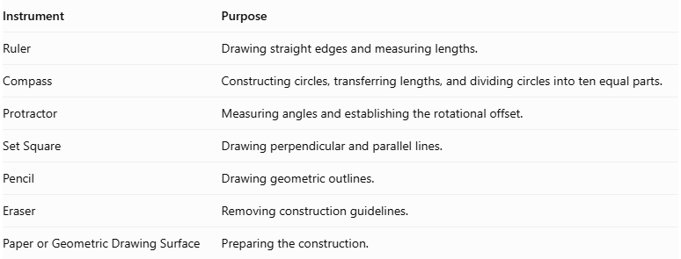
Instrument | Purpose
Ruler | Drawing straight edges and measuring lengths.
Compass | Constructing circles, transferring lengths, and dividing circles into ten equal parts.
Protractor | Measuring angles and establishing the rotational offset.
Set Square | Drawing perpendicular and parallel lines.
Pencil | Drawing geometric outlines.
Eraser | Removing construction guidelines.
Paper or Geometric Drawing Surface | Preparing the construction.

Instrument-Based Construction Procedures
# Source: AI Source: Provided by: [Data Path: Persons Table -> ID Column: 1, Name_En Column: Motasem Essam] -> From: [ChatGPT] on [7/25/2026]
The decagonal antiprism can be constructed using geometric instruments and classical geometric drawing techniques, without using coordinate-based construction.

Constructing the Lower Decagonal Base
# Source: AI Source: Provided by: [Data Path: Persons Table -> ID Column: 1, Name_En Column: Motasem Essam] -> From: [ChatGPT] on [7/25/2026]
- Draw a circle using a compass.
- Divide the circle into ten equal angular sections.
- Each central angle measures:
$$\frac{{360}^{∘}}{10}=\boxed{{36}^{∘}}$$
- Mark the ten vertices on the circumference.
- Connect consecutive vertices using a ruler to form a regular decagon.
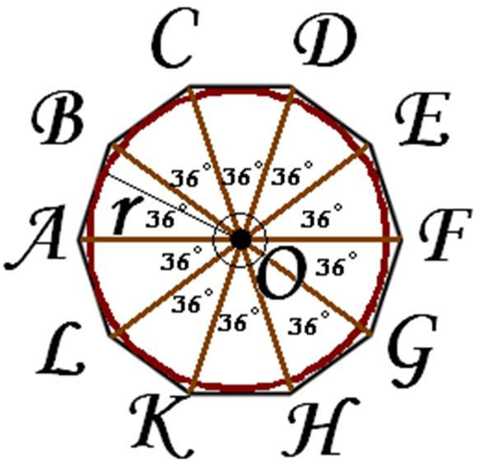

Constructing the Upper Decagonal Base
# Source: AI Source: Provided by: [Data Path: Persons Table -> ID Column: 1, Name_En Column: Motasem Essam] -> From: [ChatGPT] on [7/25/2026]
- Draw a second regular decagon congruent to the lower base.
- Position it above and parallel to the lower decagon.
- Rotate its orientation by half the central angle:
$$\frac{{36}^{∘}}{2}=\boxed{{18}^{∘}}$$
- Maintain the same side length and geometric proportions.

Connecting the Two Bases
# Source: AI Source: Provided by: [Data Path: Persons Table -> ID Column: 1, Name_En Column: Motasem Essam] -> From: [ChatGPT] on [7/25/2026]
- Connect each vertex of the lower decagon to the two nearest vertices of the upper decagon.
- Repeat the connections around the entire solid.
- Ensure the connecting edges alternate between the upper and lower bases.
- Form twenty triangular lateral faces.

Completing the Solid
# Source: AI Source: Provided by: [Data Path: Persons Table -> ID Column: 1, Name_En Column: Motasem Essam] -> From: [ChatGPT] on [7/25/2026]
- Complete all twenty triangular lateral faces.
- Emphasize the visible edges.
- Use dashed lines for hidden edges when necessary.
- Verify that both decagonal bases are congruent and parallel.
- Check that the upper base has the correct 18° rotational offset.
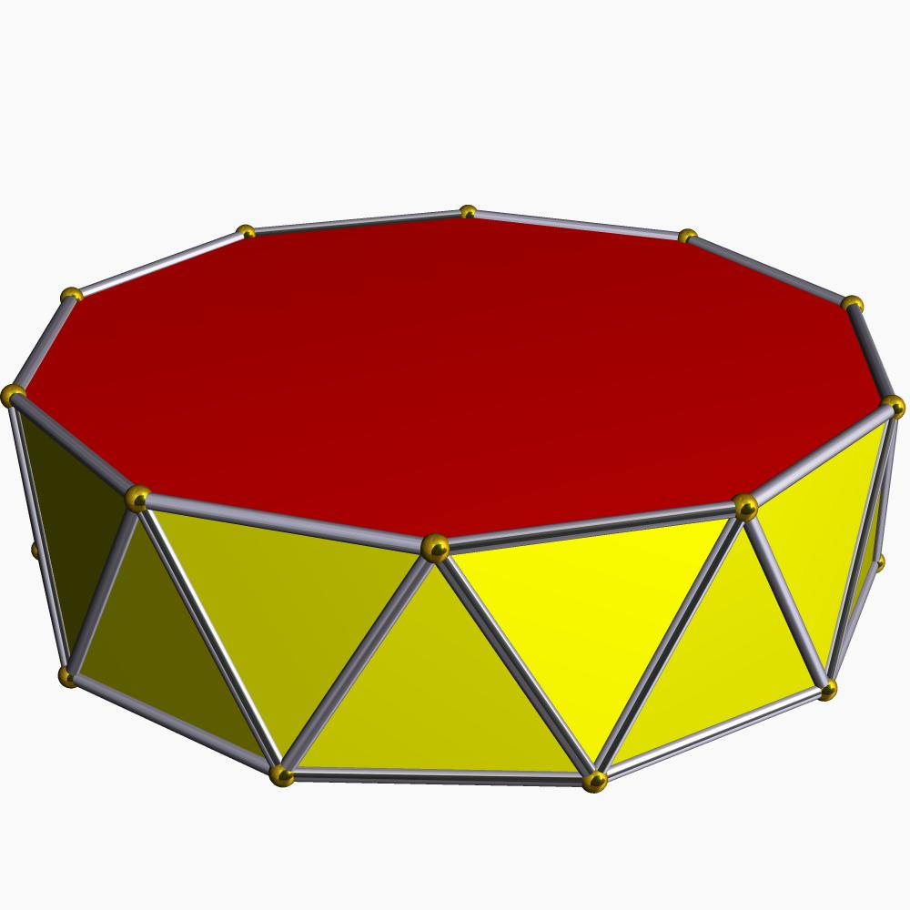

Constructing a Net
# Source: AI Source: Provided by: [Data Path: Persons Table -> ID Column: 1, Name_En Column: Motasem Essam] -> From: [ChatGPT] on [7/25/2026]
A net of a decagonal antiprism contains:
- Two congruent decagonal bases.
- Twenty triangular lateral faces.
- A connected arrangement of faces with matching edge lengths and correct face adjacency.
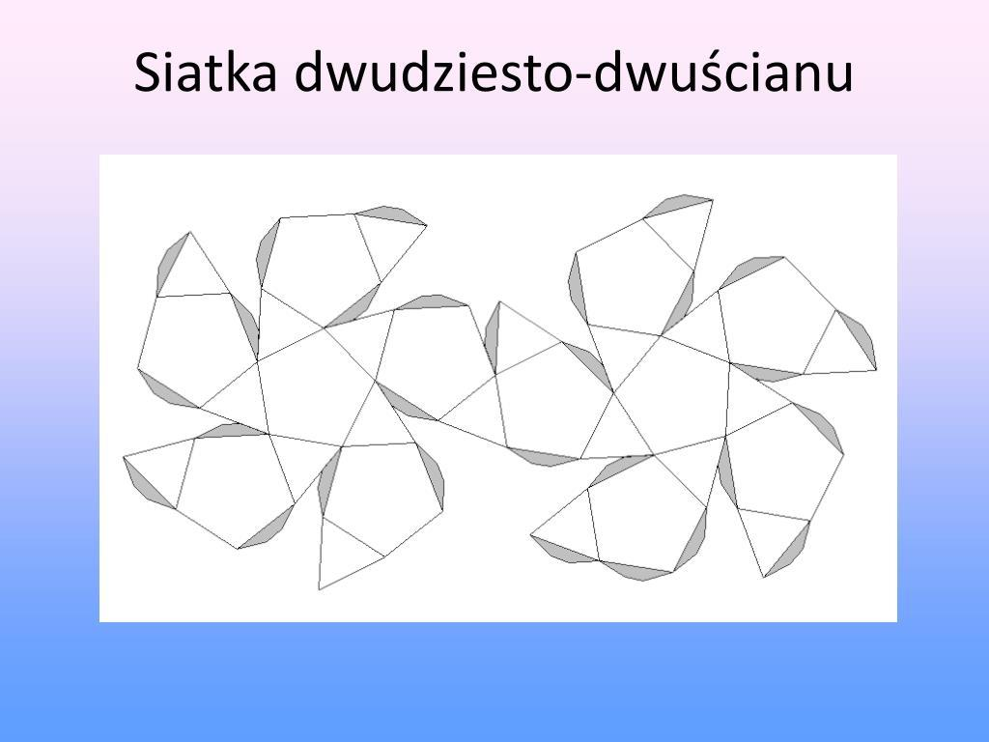

Key Points
# Source: AI Source: Provided by: [Data Path: Persons Table -> ID Column: 1, Name_En Column: Motasem Essam] -> From: [ChatGPT] on [7/25/2026]
- It has two parallel decagonal bases.
- The bases are rotated relative to each other.
- It has twenty triangular lateral faces.
- It contains 22 faces, 40 edges, and 20 vertices.
- Its regular form is a uniform polyhedron.

Classification
# Source: AI Source: Provided by: [Data Path: Persons Table -> ID Column: 1, Name_En Column: Motasem Essam] -> From: [ChatGPT] on [7/25/2026]
Solid Geometry
└── Types of Solids
└── Antiprism
└── Types of Antiprisms
└── Decagonal Antiprism
├── Upper Decagonal Base
├── Lower Decagonal Base
└── Triangular Lateral Faces

Conclusion
# Source: AI Source: Provided by: [Data Path: Persons Table -> ID Column: 1, Name_En Column: Motasem Essam] -> From: [ChatGPT] on [7/25/2026]
A Decagonal Antiprism is an antiprism with two congruent decagonal bases and twenty triangular lateral faces, arranged in a twisted configuration.

